Identifying suitable Soil Moisture Depletion Level for Ginger (Zingiber officinale) in Southwestern Ethiopia
¹Beniam Yaziz and ²Wondifraw Derib
¹ Ethiopian Institute of Agricultural Research
Bishoftu Agricultural Research Center P.O. Box: 32, Bishoftu, Ethiopia
² Ethiopian Institute of Agricultural Research ,Teppi Agricultural Research Center, P.O.Box 34 Teppi, Ethiopia
Corresponding author: beniamyaziz@gmail.com
Institutional email : beniam.yaziz@office.eair.gov.et

Abstract
This study was conducted to determine the optimal soil moisture depletion level for ginger (Zingiber officinale) under semi-arid conditions in southwestern Ethiopia, a region with favorable agro-ecological conditions but increasingly constrained by erratic rainfall. The experiment was carried out at the Teppi Agricultural Research Center over two growing seasons (2022–2023), located at 7.2° N latitude and 35.4° E longitude, with an elevation of 1,205 meters above sea level. A randomized complete block design with three replications was employed, testing six SMDL treatments (20%, 30%, 40%, 50%, 60%, and 100% of Total Available Water). Soil moisture was monitored using tensiometers and gravimetric methods, and a Boziab ginger variety was used as the test crop. Growth and yield parameters, including plant height, number of tillers, canopy cover, rhizome characteristics, and yield, were recorded and statistically analyzed. The results showed that moderate soil moisture depletion, particularly at 30% of TAW, significantly improved plant height and canopy cover, and resulted in higher rhizome width and weight, though the latter was not statistically significant. Full irrigation (100% TAW) did not offer additional benefits and may have negatively affected root zone conditions. Overall, ginger exhibited resilience across a range of water regimes, but 30% depletion provided the best balance between water use efficiency and crop performance. The main achievement of this study is the identification of 30% TAW as the optimal irrigation threshold, offering a practical strategy for improving ginger productivity and water conservation under changing climatic conditions in Ethiopia.
Keywords: Ginger, optimal soil moisture level, south west Ethiopia

INTRODUCTION
Ginger (Zingiber officinale Rosc.) is a globally valued spice crop, widely cultivated for its aromatic rhizomes, which are used both as a culinary ingredient and in traditional medicine (Akamine et al., 2010). In Ethiopia, ginger holds significant economic and agricultural importance, particularly for smallholder farmers, who rely on it as a cash crop. The country possesses favorable agro-ecological conditions for ginger cultivation and is ranked as the fourth-largest producer of ginger in Africa, following Nigeria, Mali, and Cameroon (FAOSTAT, 2020).
Despite Ethiopia’s production potential, ginger farming is geographically limited to specific regions, particularly the southern and southwestern parts of the country. Key production areas include Kambata-Tambaro, northern parts of Wolayta (Boloso Bombe and Boloso Sore), eastern Dawro (Gena Bosa), and western Meirab Badawacho in the Hadiya Zone. Collectively, these regions are referred to as the "ginger belt" of Ethiopia. In addition, ginger is cultivated to a lesser extent in Sheka, Kaffa, and Bench Sheko zones, as well as parts of southwestern Oromia and northern Amhara (Kifile et al., 2023; Masresha, 2010)
Ginger is also one of the leading spice exports from Ethiopia, contributing approximately 71% of the total spice export volume (Masresha, 2010). The export potential underscores the crop’s importance not only for rural livelihoods but also for national economic growth. However, production is increasingly threatened by both biotic and abiotic stresses. Among the most critical biotic constraints are Ginger Bacterial Wilt (GBW) caused by Ralstonia solanacearum and leaf spot disease caused by Phyllosticta zingiberi. These diseases have led to up to 100% yield losses in some areas over the past decade (Guji et al., 2019; Alemu et al., 2021), presenting a severe challenge to sustainable ginger cultivation.
In addition to disease pressures, ginger production in southwestern Ethiopia faces growing abiotic challenges, most notably due to climate variability. Farmers in these regions traditionally rely on rainfall, but erratic and insufficient precipitation, extended dry spells, and elevated temperatures during critical crop growth stages now pose major risks (Abate & Ebro, 2012). Ginger is particularly susceptible to moisture stress due to its shallow root system and high transpiration rates through its pseudo-stems (Kumar et al., 2012). These physiological characteristics make consistent and well-regulated soil moisture crucial for optimal growth and rhizome development.
Irrigation is one of the most promising interventions to mitigate the impact of unreliable rainfall, especially when applied during moisture-sensitive growth stages. However, maximizing water use efficiency in ginger requires precise irrigation scheduling and a clear understanding of the crop’s optimal soil moisture depletion threshold (Sharma & Rao, 2010). Previous studies in related spice crops, such as cardamom and turmeric, have shown that well-timed irrigation significantly enhances yield and water productivity (Madan et al., 2005; Mohanty et al., 2014). Nevertheless, such empirical data remain scarce for ginger under Ethiopian conditions.
Therefore, this study was initiated to determine the optimal soil moisture depletion level for ginger in the semi-arid climate of southwestern Ethiopia. By identifying the most effective soil moisture management strategy, the findings aim to contribute to improved irrigation practices and sustainable ginger production in the face of climatic and environmental challenges.

MATERIALS AND METHODS

Description of the study site
Field experiments were carried out at the Teppi Agricultural Research Center over two consecutive cropping seasons, specifically during 2022–2023. The research site is geographically situated at a latitude of 7.2° N and a longitude of 35.4° E, with an elevation of 1205 meters above sea level. Analysis of long-term meteorological records indicates that the site receives an average annual rainfall of approximately 1590.85 mm, while the average annual potential evapotranspiration is estimated at 1702.00 mm.
The climatic conditions of the study area are classified as semi-arid, typified by a relatively low and erratic rainfall regime, predominantly unimodal in nature. Approximately 86.4% of the annual rainfall is concentrated between May and mid-September, with the heaviest precipitation typically occurring in July and August. During this period, the mean monthly rainfall reaches its maximum in August at 236.24 mm, while the lowest mean monthly rainfall is recorded in January, at 27.7 mm.
Temperature trends in the area also show notable variation. The mean monthly maximum temperature ranges between 26.4 °C and 31.6 °C, while the mean monthly minimum temperature fluctuates between 13.4 °C and 16.5 °C. On average, the site experiences a mean maximum temperature of 28.8 °C and a mean minimum of 15.13 °C over the course of the year.

Experiment Design and procedure
The field experiment was carried out using a randomized complete block design with three replications. The plot size was 90cm by 60cm half plastic barrel (Fig.1) and the spacing between the block and plots used was 1m and 0.5m respectively. Six treatments of soil moisture depletion levels (20, 30, 40, 50, 60, and 100% of TAW) were used.

Table 1 Treatment setting for field experiment
Treatment | Description
SMDL1 | Irrigate at 20% depletion of TAW
SMDL2 | Irrigate at 30% depletion of TAW
SMDL3 | Irrigate at 40% depletion of TAW
SMDL4 | Irrigate at 50% depletion of TAW
SMDL5 | Irrigate at 60% depletion of TAW
SMDL6 | Irrigate at 100% depletion of TAW
SMDL = Soil Moisture Depletion Level; TAW = Total Available Soil Water
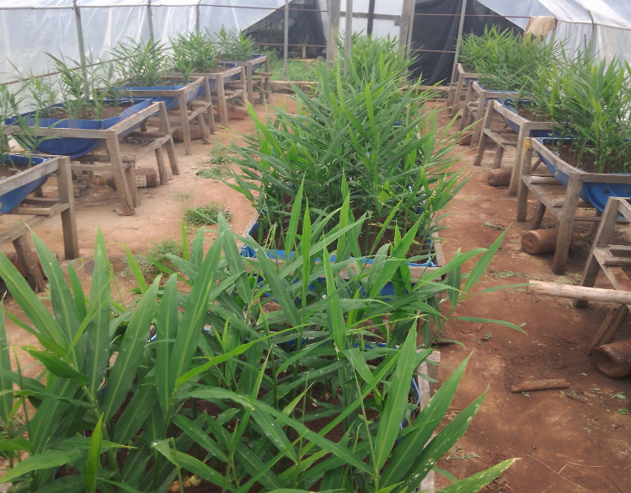
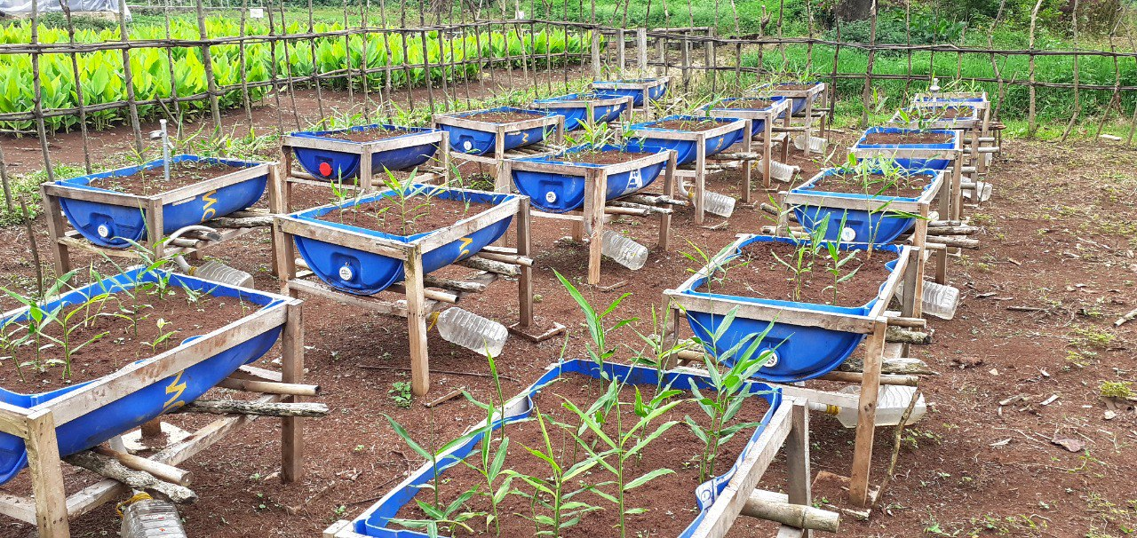
b
a
Fig1. Experimental Field layout (a &b)
A boziab variety of ginger was use as attest crop. The soil of the study area is a medium-deep clay loam, have the measured field capacity (−0.33 bar) and permanent wilting point (−15 bar) averaging 29.57 and 18.08% by weight, respectively. Extractable plant water is estimated as 127.06mm/m in the rooting depth and a bulk density of 1.29 g/cm3 . All agronomic practices were applied uniformly for all plots. Irrigation water was applied to refill the soil moisture to the field capacity level by measuring the designed soil moisture depletion levels via a Tensiometer installed at the required root depth. The soil moisture depletion levels of more than 50% of TAW were measured gravimetrically

Soil Water Content Determination
Oven dry (Gravimetric) method
The oven-dry method (Hillel, 2004) is one of the most popular ways to assess soil moisture content. A soil sample weighing about 200 grams is taken, its precise weight is recorded, and the sample is dried for 24 hours at 105 ℃ in an oven. After the sample is weighed, the moisture loss is calculated by deducting the oven-dry weight from the moist weight. Moisture content is expressed as a percentage of the oven-dry weight of the soil:
$$Gravimetric water content\left(\%\right)=\frac{weight of wet soil \left(gm\right)– the weight of dry soil \left(gm\right)}{Weight of dry soil \left(gm\right)}*100$$
$$Volumetric water content \left( \% \right)=Gravimetric water content \left( \% \right)X BD \left(\frac{gm}{m^{3}}\right)$$
$$Depth of water d (mm/m) = Volumetric water content (\%) × Root depth D (mm)$$
Readily Available Soil Moisture / Allowable Soil Moisture Depletion is the portion of the total available water (FC – PWP) that is most easily extracted by the plant roots without creating stress(Allen et al., 1998a; Al-Kaisi and Broner, 2009). The water content approaching PWP cannot be easily extracted by the plant roots. Therefore, only part of the TASW is used before the next irrigation. The term Maximum/management Allowable Deficiency, MAD, can be used to compute the amount of water that can be used without adversely affecting the plants and can be expressed as a fraction of the TASW. This value varies with the crop type and could be obtained experimentally. Once the MAD is known, it is possible to compute the net irrigation water requirement necessary to restore the main root zone to Field capacity. Using the following equation, the MAD for any type of soil is determined (Allen et al., 998a).
$$MAD/P(Fraction)=\frac{RASM}{TASW}$$

Data collection and analysis
Observations on the plant height, \number of tillers per plant, number of leaves per plant, canopy cove, number of mother rhizomes per plant, number of primary rhizomes per plant, number of secondary rhizomes per plant, and yield were recorded. Fresh rhizome yield per plot was calculated for a 5.76 m2 sampled plot area excluding the borders from all sides. The collected data were analyzed using statistical analysis system (SAS) software using the general linear model GLM). Mean separation was carried out using LSD at a 5% probability level to compare the differences among the treatments' mean

RESULTS AND DISCUSSION
Table 1 Effect of Soil Moisture Depletion on Ginger Growth Parameters
Treatment | Ph cm | NTPP | CC_m2
20% TAW | 30.33^{ab} | 2.89ª | 0.02^{ab}
30% TAW | 35.05ª | 2.89ª | 0.02^{ab}
40% TAW | 33.11^{ab} | 2.86ª | 0.02ª
50% TAW | 32.00^{ab} | 2.22ª | 0.01^{b}
60% TAW | 31.66^{ab} | 1.92ª | 0.01^{b}
100% TAW | 27.55^{b} | 1.65ª | 0.01^{ab}
Mean | 30.947 | 2.405 | 0.014
LSD at 0.05 | 7.6 | ns | 0.009
CV(%) | 9.55 | 21.75 | 35

Plant Height
The results clearly indicate that ginger plant height was significantly influenced by the levels of soil moisture depletion (LSD = 7.6, p < 0.05). The tallest plants were recorded under the 30% TAW depletion level, with an average height of 35.05 cm. This was significantly higher than the 100% TAW treatment (27.55 cm), which consistently produced the shortest plants. The 40% TAW treatment also yielded relatively taller plants (33.11 cm), statistically comparable to the 20%, 50%, and 60% treatments. These findings suggest that mild to moderate water stress, particularly at 30% and 40% depletion, promotes better vertical growth, possibly due to the activation of adaptive growth responses that optimize shoot elongation under limited water conditions. Conversely, full irrigation (100% TAW) may have led to excess soil moisture, reducing root aeration and nutrient uptake efficiency, ultimately suppressing plant height.

Number of Tillers per Plant
Unlike plant height, the number of tillers per plant was not significantly affected by different TAW depletion levels (ns at p < 0.05). Tiller numbers ranged narrowly from 1.65 (100% TAW) to 2.89 (20% and 30% TAW). This suggests that tiller formation in ginger may be less sensitive to soil moisture variations within the tested range, or that other factors such as genetic expression or soil nutrient status play a more dominant role in tillering. The coefficient of variation (CV = 21.75%) indicates moderate experimental variability.

Canopy Cover
Canopy cover exhibited statistically significant differences (LSD = 0.009, p < 0.05) among treatments. The highest canopy cover (0.02 m²) was recorded at 30% and 40% TAW depletion, supporting the hypothesis that mild water stress enhances vegetative expansion. Treatments with higher depletion levels (50% and 60%) showed reduced canopy development (0.01 m²), suggesting moisture limitations impaired leaf area expansion. Interestingly, 100% TAW, while better than 50% and 60%, did not significantly outperform other treatments, which may again be linked to suboptimal root zone conditions under full irrigation. The high CV (35%) denotes substantial variation among replicates, which may be attributable to uneven plant development or micro-environmental differences.
Table2 Effect on Rhizome Development and Yield Components
Treatment | NO. of Finger Rhizome | Rhizome Length (cm) | Rhizome Width (cm) | Five Rhizome weight (gram)
20% TAW | 4.4 | 10.1 | 31.73 | 133.53
30% TAW | 4.6 | 9.87 | 38.2 | 140.47
40% TAW | 4.47 | 9.9 | 35.76 | 101.67
50% TAW | 4.2 | 15.93 | 30.64 | 120.33
60% TAW | 4.27 | 10.19 | 31.37 | 128.33
100% TAW | 4.2 | 9.27 | 32.22 | 140
Mean | 4.36 | 10.88 | 33.32 | 127.39
LSD at 0.05 | ns | ns | ns | ns
CV(%) | 9.17 | 43.34 | 15.77 | 32.48

Number of Finger Rhizomes
Although not statistically significant, the number of finger rhizomes varied slightly across treatments. The highest mean was observed at 30% TAW (4.6), with the lowest (4.2) at 50% and 100% TAW. These results suggest that a slight water deficit does not impair rhizome branching and may even stimulate rhizogenesis through improved assimilate partitioning, as supported by Kumar et al. (2012).

Rhizome Length and Width
Rhizome length peaked under 50% TAW (15.93 cm), though this was statistically insignificant and highly variable (CV = 43.34%). The 100% TAW treatment produced the shortest rhizomes (9.27 cm). Interestingly, despite moderate stress, rhizome girth (width) was greatest at 30% TAW (38.2 cm), suggesting that under slight stress, plants may favor girth over elongation as a survival strategy to store carbohydrates. However, due to high variability and non-significance, definitive conclusions cannot be drawn.

Rhizome Weight
The weight of five rhizomes was highest at 30% TAW (140.47 g), nearly equal to that at 100% TAW (140 g), while the lowest weight was observed at 40% TAW (101.67 g). Although numerically superior, the differences were not statistically significant. Still, the data hint at the potential benefit of 30% TAW in maximizing biomass accumulation under moderate irrigation. This aligns with findings from turmeric under regulated irrigation (Sharma & Rao, 2010), indicating a similar response pattern in related rhizomatous crops.

Synthesis and Agronomic Implications
The overall analysis demonstrates that moderate moisture depletion—particularly at 30% TAWtends to promote better vegetative growth (height, canopy cover) and favorable rhizome development traits (weight, width) without causing significant physiological stress. Conversely, full irrigation (100% TAW) did not result in improved growth or yield and may have created suboptimal soil conditions, such as poor aeration or leaching of nutrients. The non-significant response in yield components across treatments indicates resilience of ginger to a range of water availabilities but highlights the economic and water-saving advantages of moderate irrigation.
These results underscore the importance of irrigation scheduling tailored to crop-specific moisture sensitivity. Given ginger’s high market value and shallow rooting system, managing soil moisture at 30–40% depletion appears optimal under the semi-arid conditions of Southwestern Ethiopia.

CONCLUSION
This study investigated the influence of varying soil moisture depletion levels on the growth and yield parameters of ginger (Zingiber officinale) in Southwestern Ethiopia. The findings reveal that ginger responds positively to moderate water stress, particularly at 30% and 40% depletion of Total Available Water (TAW). These levels promoted superior vegetative growth, as evidenced by significant improvements in plant height and canopy cover, while also supporting higher (though statistically non-significant) values for rhizome width and weight.
Full irrigation (100% TAW) did not confer additional benefits and may have hindered optimal growth due to poor root zone conditions. Additionally, no significant differences were observed in the number of finger rhizomes, rhizome length, or tiller production across treatments, suggesting that these traits are relatively stable across a wide moisture spectrum.
In conclusion, the optimal soil moisture depletion level for ginger cultivation in the study area is approximately 30% of TAW, which balances water use efficiency with optimal plant performance. This finding is particularly relevant for enhancing ginger production under changing climate and water-limited conditions in Ethiopia. Adoption of such irrigation scheduling could contribute significantly to increased ginger productivity, reduced water use, and improved livelihoods for smallholder farmers in the region.

ACKNOWLEDGEMENT
The authors are grateful to Natural Resource Management Research Directorate, Ethiopian Institute of Agricultural Research, for providing funds for the experiment. They are also thankful to technical and field assistance and all staff members of Natural Resource Management Research Process, Teppi Agricultural Research Center for their support and technical assistance in the field experimentation.

REFERENCES
Abate, T., & Ebro, A. (2012). Assessment of climate change impacts on the livelihood of smallholder farmers in Ethiopia. African Journal of Agricultural Research, 7(32), 4592-4599.
Akamine, H., Kawamitsu, Y., & Sakai, H. (2010). Effect of shading on growth and yield of ginger (Zingiber officinale Rosc.). Plant Production Science, 13(3), 278–283.
Alemu, T., Wondimu, T., & Woldetsadik, K. (2021). Evaluation of ginger (Zingiber officinale Rosc.) cultivars for bacterial wilt resistance in southwestern Ethiopia. African Crop Science Journal, 29(1), 23–34.
BOARD (Bureau of Agriculture and Rural Development). (2008). Annual Report on Crop Production and Market Trends. SNNPR, Ethiopia.
FAOSTAT. (2020). Food and Agriculture Organization of the United Nations. Statistical Database.
Guji, R., Adugna, G., & Terefe, H. (2019). Distribution and intensity of ginger bacterial wilt (Ralstonia solanacearum) in southern Ethiopia. Journal of Plant Pathology & Microbiology, 10(2), 485.
Kumar, V., Singh, B., & Meena, R. (2012). Effect of water stress on growth, yield and quality of rhizome crops: A review. Indian Journal of Agricultural Sciences, 82(3), 211–217.
Kumar, V., Singh, B., & Meena, R. (2012). Effect of water stress on growth, yield and quality of rhizome crops: A review. Indian Journal of Agricultural Sciences, 82(3), 211–217.
Madan, M. S., Shankara, M. G., & Roy, T. S. (2005). Effect of irrigation regimes on yield and quality of cardamom (Elettaria cardamomum). Journal of Spices and Aromatic Crops, 14(1), 1–6.
Masresha Yimer. (2010). Export performance of Ethiopian spices: An overview. Ethiopian Horticulture Development Agency, Addis Ababa, Ethiopia.
Mohanty, S. K., Singh, A., & Jena, S. (2014). Impact of drip irrigation and mulch on growth and yield of turmeric (Curcuma longa L.). Indian Journal of Agronomy, 59(3), 469–472.
Nelson, S. C. (2013). Ginger root and rhizome diseases. University of Hawaii Cooperative Extension Service, Plant Disease PD-96.
Sharma, R., & Rao, K. V. (2010). Irrigation scheduling and water-use efficiency in turmeric (Curcuma longa L.) under varying moisture regimes. Journal of Medicinal and Aromatic Plant Sciences, 32(4), 401–405.
Sharma, R., & Rao, K.V. (2010). Irrigation scheduling and water-use efficiency in turmeric (Curcuma longa L.) under varying moisture regimes. Journal of Medicinal and Aromatic Plant Sciences, 32(4), 401–405.

